

# Ground Penetrating Radar – Reflections from Westminster Abbey & Holy Trinity Stratford

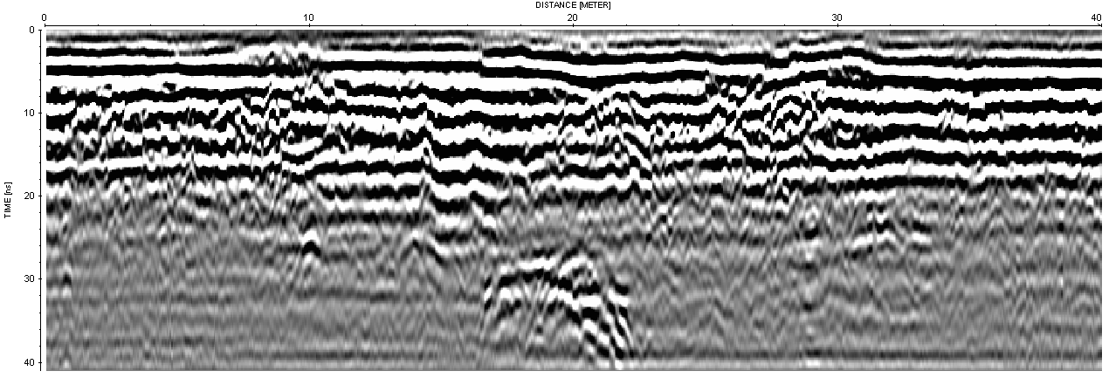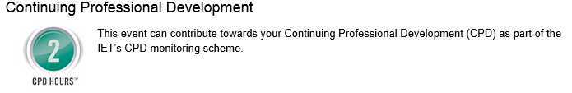

Erica Utsi studied mathematics and archaeology at the Universities of St. Andrews and Cambridge respectively. Subsequently, she co-founded Utsi Electronics, a specialist electronics company which designs and produces Ground Penetrating Radar (GPR) systems for general use and specialist and novel applications, retiring from the company in 2015.

She is currently Principal of EMC Radar Consulting, and a former chairman of the European Ground Penetrating Radar Association.

Erica has been carrying out an ongoing investigation into the hidden secrets of Westminster Abbey over the last 13 years, and conducted the GPR work on the first archaeological investigation of Shakespeare’s grave at Holy Trinity Church in Stratford-on-Avon.

Erica Utsi, a renowned expert in the field of Ground Penetrating Radar, will describe the application of this technology to exploring the archaeological secrets which lie beneath our feet.

The talk will begin with a short description of Ground Penetrating Radar (GPR) technology and the many uses to which it is commonly put.  Images generated from Westminster Abbey and Holy Trinity Church in Stratford will then be used to illustrate the usefulness of the technique.

**Contact Name:** Hugh Woodward ([hwoodw2928@aol.com](mailto:hwoodw2928@aol.com))

**Date & Time:** January 18th 2018 at 7.00pm, Refreshments from 6.30pm

**Venue:** Faraday Lecture Theatre, Swansea University, Singleton Campus

**Registration:** Members of the public are warmly welcomed to this free event – registration is not essential but would be helpful:

<http://www.theiet.org/events/local/251236.cfm>

**Other information:** This is a joint event with Swansea Amateur Radio Society